**Deep Learning Architecture**

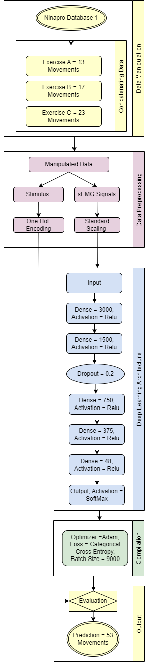

**Figure**: Deep Learning Architecture

**TSNE (3 Component) Machine Learning Algorithm Results for Each Exercise of Subject 1**

**Time Calculations:**

|  |  |  |  |  |
| --- | --- | --- | --- | --- |
| Algorithms | Exercise A  Movement = 13 | Exercise B  Movement = 17 | Exercise C  Movement = 23 | All Movements  Movement = 53 |
| Decision Tree Classifier | 1.441 | 4.898 | 11.136 | 19.463 |
| KNeighbors Classifier | 0.009 | 0.019 | 0.035 | 0.079 |
| Random Forest | 59.697 | 114.954 | 197.935 | 552.169 |
| Extra Trees Classifier | 13.503 | 15.302 | 17.373 | 85.729 |
| XGBoost | 143.805 | 147.139 | 335.742 | 1530.200 |

**Table:** Comparison of Time Calculations (Seconds)

**Accuracy Results:**

|  |  |  |  |  |
| --- | --- | --- | --- | --- |
| Algorithms | Exercise A  Movement = 13 | Exercise B  Movement = 17 | Exercise C  Movement = 23 | All Movements  Movement = 53 |
| Decision Tree Classifier | 85.009% | 87.647% | 92.641% | 87.282% |
| KNeighbors Classifier | 88.661% | 89.956% | 94.082% | 89.844% |
| Random Forest | 88.341% | 90.169% | 94.205% | 90.328% |
| Extra Trees Classifier | 88.421% | 90.318% | 94.506% | 90.429% |
| XGBoost | 87.488% | 88.575% | 89.462% | 84.872% |

**Table:** Comparison of Accuracy.

**F1 Score Results:**

|  |  |  |  |  |
| --- | --- | --- | --- | --- |
| Algorithms | Exercise A  Movement = 13 | Exercise B  Movement = 17 | Exercise C  Movement = 23 | All Movements  Movement = 53 |
| Decision Tree Classifier | 0.850 | 0.877 | 0.926 | 0.873 |
| KNeighbors Classifier | 0.882 | 0.898 | 0.940 | 0.895 |
| Random Forest | 0.881 | 0.899 | 0.941 | 0.901 |
| Extra Trees Classifier | 0.882 | 0.902 | 0.945 | 0.902 |
| XGBoost | 0.869 | 0.883 | 0.893 | 0.843 |

**Table:** Comparison of F1 Score.

**Results of every 8 movements of Exercise C**

**Time Calculations:**

|  |  |  |  |  |
| --- | --- | --- | --- | --- |
| Algorithms | Exercise C  Movement  (0-7) | Exercise C  Movement  (8-15) | Exercise C  Movement  (16-23) | Exercise C  All Movements  (0-23) |
| Decision Tree Classifier | 0.922 | 0.356 | 0.394 | 3.290 |
| KNeighbors Classifier | 0.641 | 0.089 | 0.097 | 1.335 |
| Random Forest | 27.012 | 10.903 | 8.663 | 57.877 |
| Extra Trees Classifier | 26.867 | 3.437 | 3.459 | 59.279 |
| XGBoost | 81.559 | 16.425 | 18.641 | 237.172 |

**Table:** Comparison of Time Calculations (Seconds)

**Accuracy Results:**

|  |  |  |  |  |
| --- | --- | --- | --- | --- |
| Algorithms | Exercise C  Movement  (0-7) | Exercise C  Movement  (8-15) | Exercise C  Movement  (16-23) | Exercise C  All Movements  (0-23) |
| Decision Tree Classifier | 95.842% | 89.913% | 92.224% | 90.423% |
| KNeighbors Classifier | 98.749% | 97.747% | 98.945% | 97.266% |
| Random Forest | 98.516% | 97.579% | 98.192% | 97.092% |
| Extra Trees Classifier | 98.591% | 98.117% | 98.794% | 97.164% |
| XGBoost | 97.642% | 96.032% | 96.986% | 93.591% |

**Table:** Comparison of Accuracy.

**F1 Score Results:**

|  |  |  |  |  |
| --- | --- | --- | --- | --- |
| Algorithms | Exercise C  Movement  (0-7) | Exercise C  Movement  (8-15) | Exercise C  Movement  (16-23) | Exercise C  All Movements  (0-23) |
| Decision Tree Classifier | 0.958 | 0.899 | 0.922 | 0.904 |
| KNeighbors Classifier | 0.987 | 0.977 | 0.989 | 0.973 |
| Random Forest | 0.985 | 0.976 | 0.982 | 0.971 |
| Extra Trees Classifier | 0.986 | 0.981 | 0.988 | 0.971 |
| XGBoost | 0.976 | 0.960 | 0.969 | 0.935 |

**Table:** Comparison of F1 Score.

**Deep Learning Algorithm Results**

**Time Calculations:**

|  |  |  |  |  |
| --- | --- | --- | --- | --- |
| Algorithms | Exercise C  Movement  (0-7) | Exercise C  Movement  (8-15) | Exercise C  Movement  (16-23) | Exercise C  All Movements  (0-23) |
| Deep Learning | 14835.723 | 3389.308 | 3794.938 | 22565.775 |

**Table:** Comparison of Deep Learning Time Calculations (Seconds)

**Accuracy Results:**

|  |  |  |  |  |
| --- | --- | --- | --- | --- |
| Algorithms | Exercise C  Movement  (0-7) | Exercise C  Movement  (8-15) | Exercise C  Movement  (16-23) | Exercise C  All Movements  (0-23) |
| Deep Learning | 99.367 | 97.377 | 98.583 | 97.899% |

**Table:** Comparison of Deep Learning Accuracy Score.

**F1 Score Results:**

|  |  |  |  |  |
| --- | --- | --- | --- | --- |
| Algorithms | Exercise C  Movement  (0-7) | Exercise C  Movement  (8-15) | Exercise C  Movement  (16-23) | Exercise C  All Movements  (0-23) |
| Deep Learning | 0.994 | 0.974 | 0.986 | 0.979 |

**Table:** Comparison of Deep Learning F1 Score.